How to Use Presenter View in PowerPoint 2010 (View Notes Privately)
PowerPoint “Presenter View” is a great option to view your presentation with Notes on presenter computer (your laptop), and while the audience will view notes-free presentation on the other display/monitor (like Projected screen). Lets see how to use Presenter View option on PowerPoint 2010 and connect second monitor/display.

Prerequisites: Make sure your computer supports the use of multiple monitors, most computers these days support to use multiple monitors, check your computer manufacturer’s website.

Step-1
Open your presentation file in PowerPoint 2010

Step-2

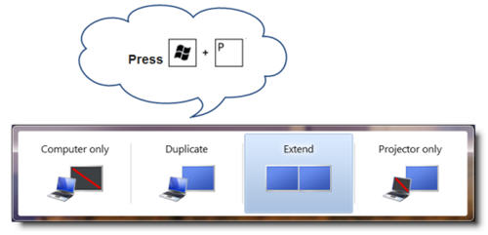

-3
Now go back to PowerPoint and make sure “Use Presenter View” is checked
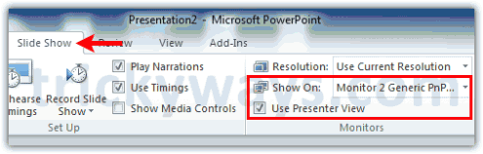
To run the presentation hit the F5 key from keyboard, you will see presentation view is different on both displays
Presentation view on presenter computer monitor will look like this:
- Notes area
- Slide view
- Slides thumbnails
- Elapsed time and more
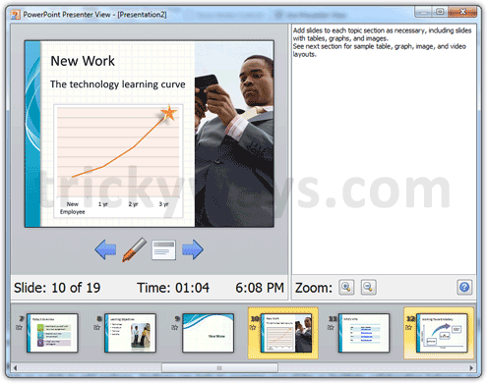
Presentation view for Audience on 2nd display will look like this:
